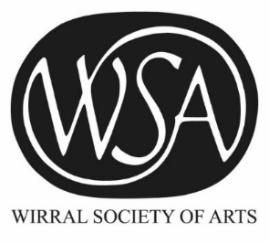
Wirral Society of Arts

www.wirralsocietyarts.org

www.facebook.com/wirralsocietyofarts

A P P L I C A T I O N F O R M E M B E R S H I P
Name:

Address:

Email address:

Telephone:

Website:

Details of works submitted:

This section may be expanded as necessary [just keep typing!].

About you / artist’s statement:

This section may be expanded as necessary [just keep typing!].
Applications for membership are considered approximately every three months and the timetable for the next applications for membership is shown below. Please submit three works, presented as you would for an exhibition, along with any accompanying sketchbooks, etc. to the Williamson Art Gallery, Slatey Road, Birkenhead, Wirral CH43 4UK.

Timetable: The next selection meeting will be on 29 November 2018.
Email this form to: info@wirralsocietyarts.org by 26 November 2018 at the very latest.
Please deliver your work to the Williamson on either 28 or 29 November 2018 [10am - 5pm].
Please collect your work on 30 November or as soon as possible after that [10am-5pm].

Fair Processing Notice. The information you have provided on this form will be processed in accordance with the Data Protection Act 1998 and the EU General Data Protection Regulation. We will only use it to process your application and to keep in touch with you about membership and the activities of the WSA. We will not pass your information on to 3rd parties or use it for marketing purposes.

